Become familiar with this dataset as we will be using both this and the avengers data set for your capstone project.

Make a series of queries that meet the following requirements. Write a paragraph about each one including a general overview of the process (i.e. talk about functions in sql), the expected result, the actual query, and a screenshot of the result.

-set operations

-subqueries

-order of operation of queries

-creating, altering, and dropping tables

-associations

-joins and multiple table joins

My 1st set of queries are for making a new Table. Table will have Titles with “Moutain” in them.(Note: as you can see in screen shot I have *Where TITLE like '%mountain%' or '%MT%';* this also worked but didn’t work for Creating table... so I omitted “MT”, which from output can see produced same number of rows) I Then Altered the table Title Column to better reflect and down the road in my queries easier to manage.... **Title to MT_Title**

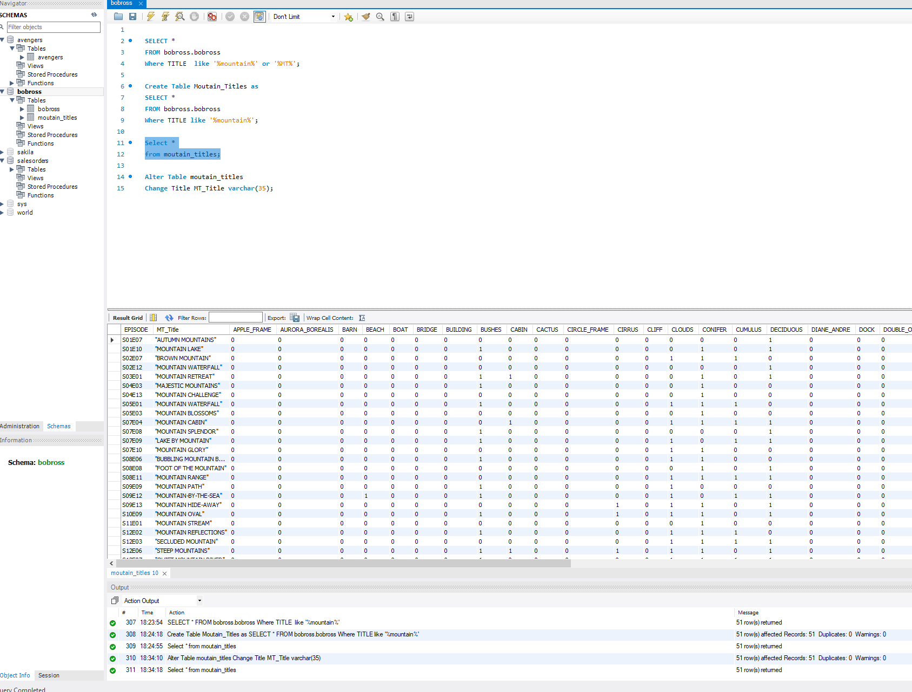

My 2nd queries is a join with the table I just created and where I grouped them by episodes. I know I am not getting the best data back with my Join. I tried a few things, but ultimately think its because the 2 tables are 2 much alike and have same data. What Joins allow a person to do is extract Data from other tables to use in the query/table you are creating. Very similar to subqueries, but subqueries allow you to get a single piece of data... Which can be useful in aggregate functions. Also on Joins.. Using right join vs left join...Right join will return all rows on that side even if there are no matches... Left joins will return all rows on that side even if there is no matches … See my screen shot of output.

You can see that the association between the 2 tables I am using are with the Apple_frame. By associating the 2 allows me to join them

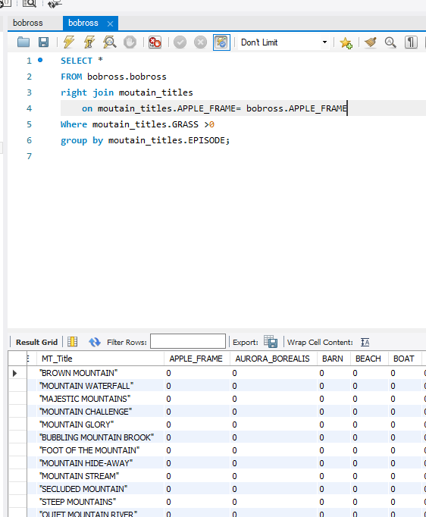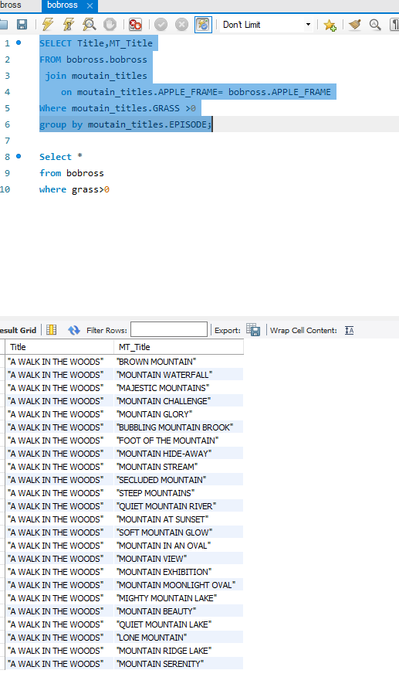

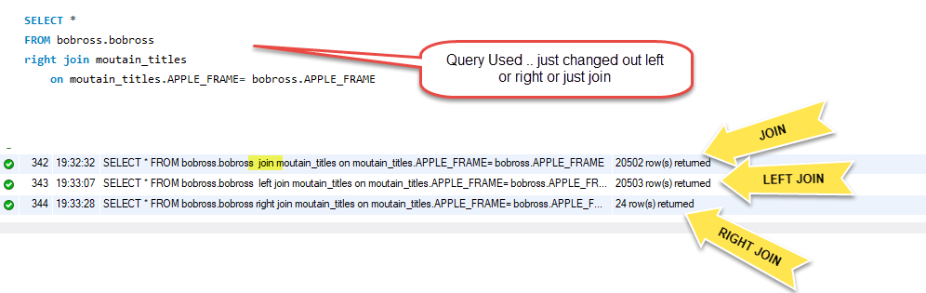

My 3rd Queries are for “set operations” …"Union” and “Union All”.(Note: Minus, intersect and except are not available in MySql) and Didn’t know about “set operations” until doing this assignment. I also learned that its more useful if the 2 tables have identical data or mostly vs Joins. What Union does vs Union all is Union omits the duplicats. I also learned that the first Select, in the union, will use that title from that table ..IE Mountain_titles first will have heading of MT_Title. It also appears to be similar to a left/right join because I get different number of rows depending on which table I use first.

The association between the 2 tables in these queries are using the Set operations. Which is similar to Joins but easier to read.

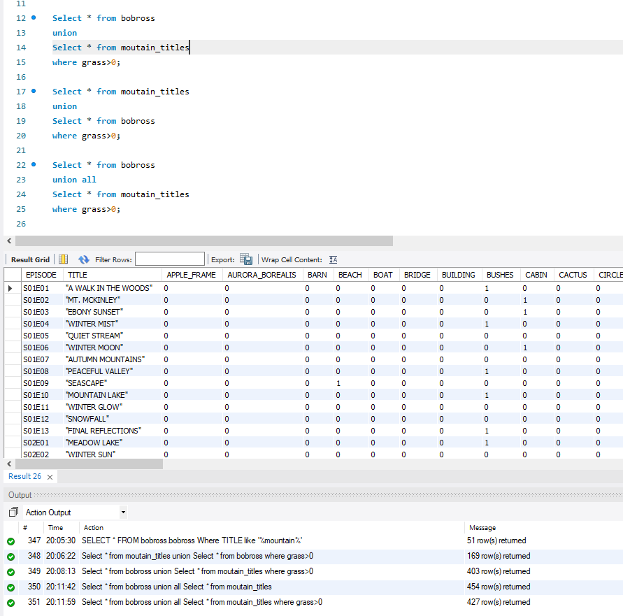

My 4th query shows subqueries. Normally I would use subquerries with aggregate function, but unsure how approach it with this data. So the example I am using is similar to the 1st query..What I am doing is using a subquery to get all MT_titles from the Moutain_Title database that contain “su” using the Like function.

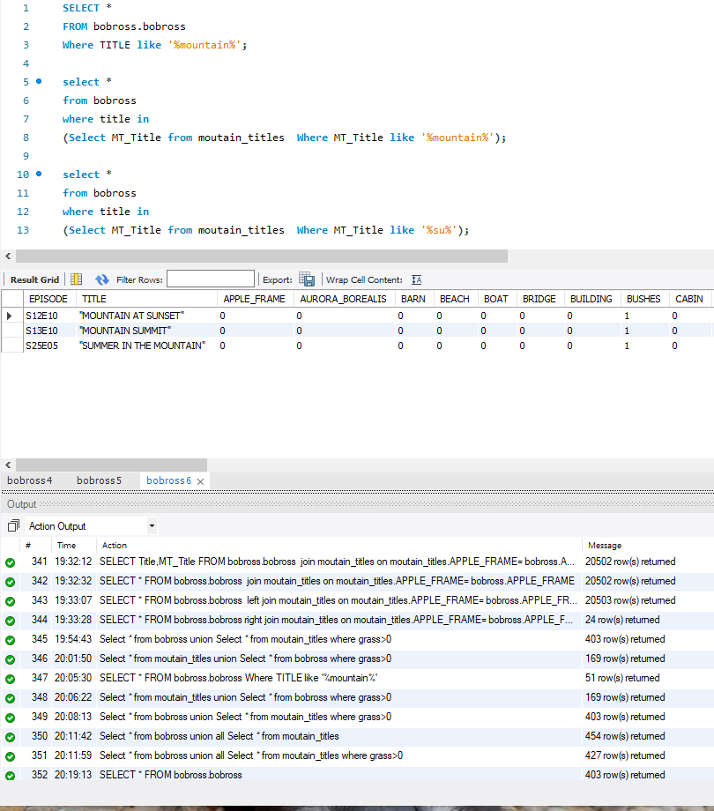

I hope that I have demonstrated all that was required for this assignment. I know some explanations are short in explaining but I do understand these queries. I was drawing blank on creating tables to help with showing them. Hence the only one table.